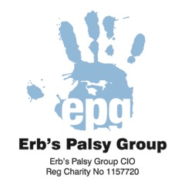 THE ERBS PALSY GROUP CIO
UK Registered Charity Number: 1157720 CIO
THE TIM DYDE FUND FOR GIFTED INDIVIDUALS APPLICATION FORM

Please read the Fund Guidelines carefully before completing this form to ensure that you are eligible and that your application falls within our guidelines. In the event of doubt please contact one of our Trustees.

- You may provide additional information on attached sheets.

- It is important that you provide all the information that is requested. Applications may be meritorious but if the form is incomplete we may have insufficient information to give proper consideration to your application.

Name of applicant:

Date of Birth of applicant:

Contact details of applicant:
Address

Email
Telephone

Name of Person making the application (if different to above):

Contact details of above (if different to the applicant):
Address

Email
Telephone

Relationship to applicant:

Erb’s Palsy Group Membership Number:

Please provide information as to why this application is being made:

Please include details as to the applicant’s particular talent, skill or gift
Whether this has been recognised by an independent body
Why funding is needed
Personal aims/goals and how this is likely to support or further the applicant’s pursuit of those aims and goals.

Cost of item/event: £  Please provide evidence of cost and where appropriate that it represents value for money – please see guidance. | Amount already raised/funded:  £
Amount requested: £

I confirm that the above statement is true and that all the information provided in this application is correct.

Signature: __________________________________ Date: __________________________

